Lesson 02 Demo 03

Creating a Pull Request in Git

Objective: To create a pull request for merging the local changes into a remote Git repository

Tools required: Git and GitHub

Prerequisites: You need to have Git installed to proceed with this demo.

Steps to be followed:
- Create a fork
- Clone the fork
- Sync the fork with the original repository
- Push changes to the GitHub fork
- Create a pull request

Step 1: Create a fork

- Open the browser in your lab, go to github.com, and log in to your account

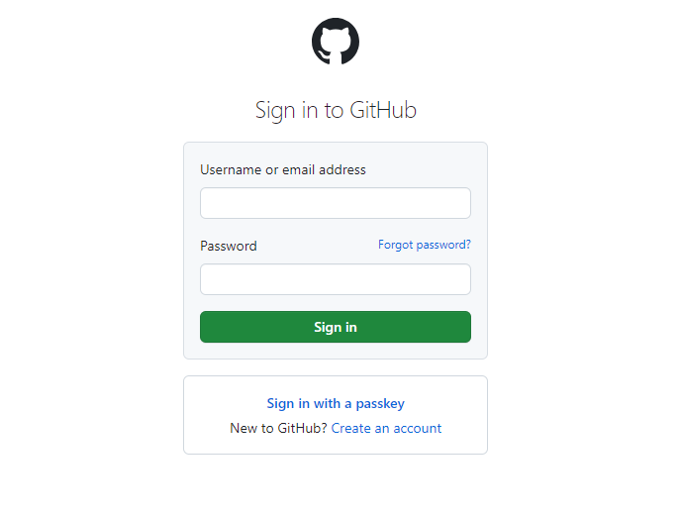
Note: If you do not have a GitHub account, visit the official website at https://github.com/signup and create a new account

- Navigate to the following repository in your browser:
https://github.com/GithubResources1/Chat-Application

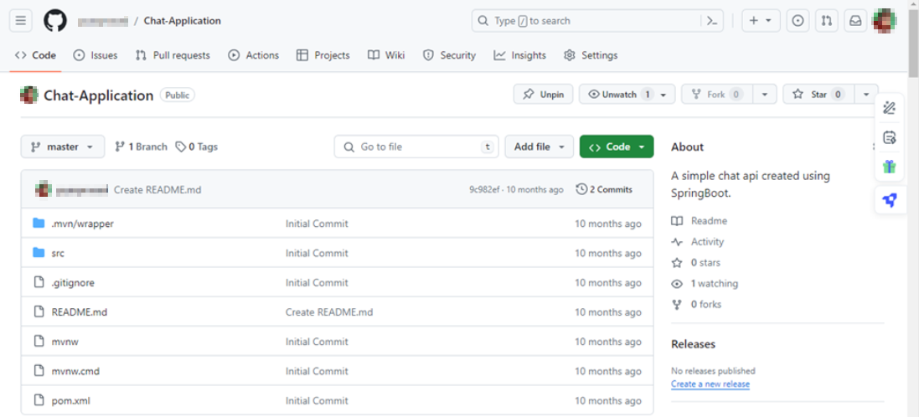

- Click the Fork button in the top-right corner of the page

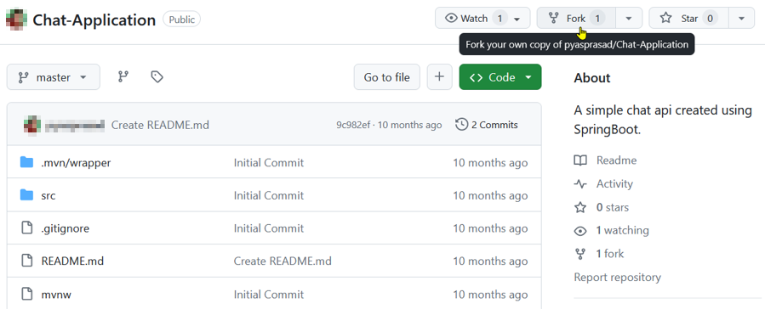

- In the Create a new fork page, enter the name and description of the forked repository, then click on Create fork

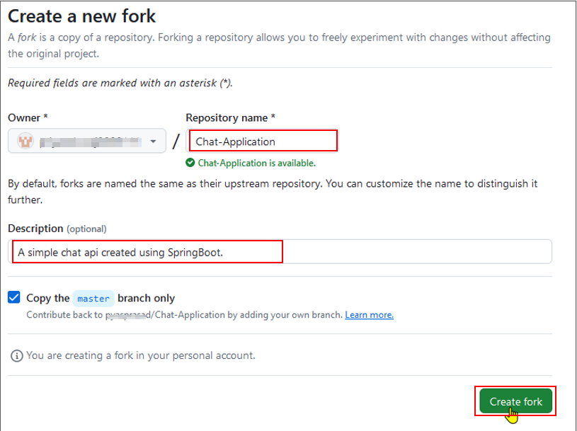

Step 2: Clone the Fork

- Click on the Code button in the forked repository page

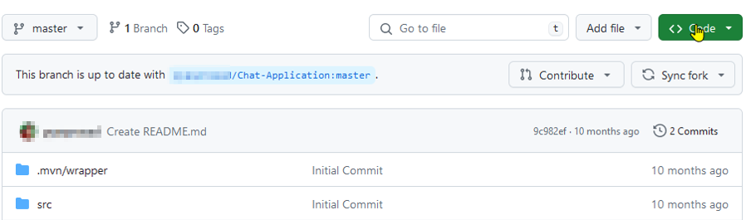

- Click on the copy icon to copy the HTTPS URL of the forked repository to clone it

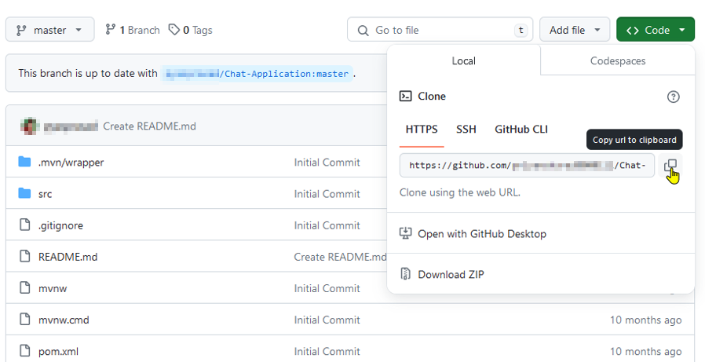

- Open the terminal tab on your lab and use the following command to clone the forked repository inside the local project directory:
git clone <URL>

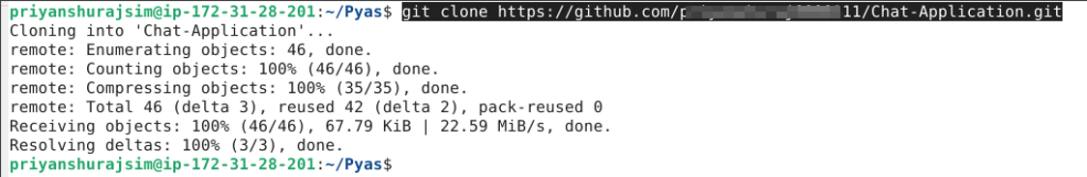
Note: Replace the URL with the copied HTTPS URL from the repository

Step 3: Sync the fork with the original repository

- Navigate to the directory where the fork has been cloned using the following command in the terminal:
cd Chat-Application

- Run the following command to view the configured remote repository for your fork:
git remote -v

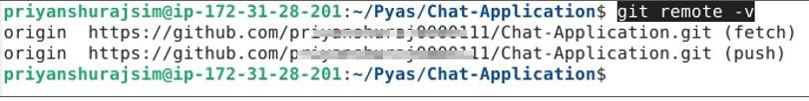

- Add the original repository as a remote upstream using the following command:
git remote add upstream <URL>

Note: Replace the URL with the copied URL from the repository

- Execute the following command to verify the new upstream repository:
git remote -v

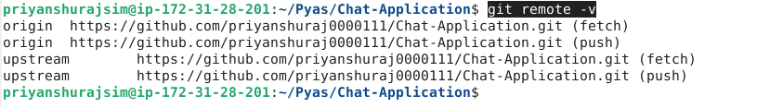

Step 4: Push changes to the GitHub fork

- After making changes in the local code repository, execute the following command to push the changes to your GitHub fork:
git push

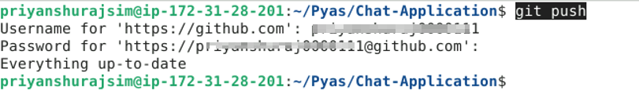
Note: After executing the Git push command, you will be asked to enter the username and password for your GitHub account.

Step 5: Create a pull request

  - Click the Pull requests button on your GitHub fork’s page

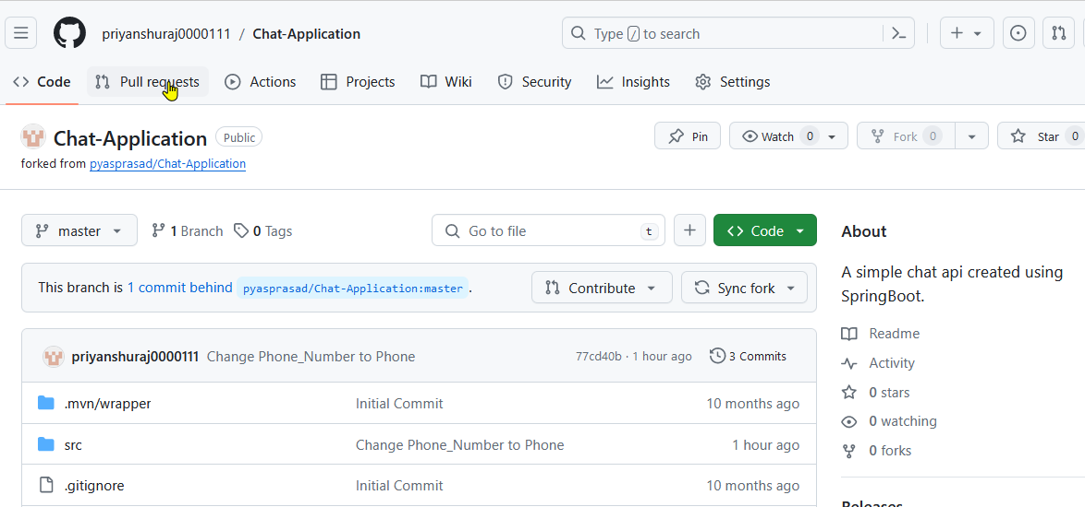

  - Click the New pull request button

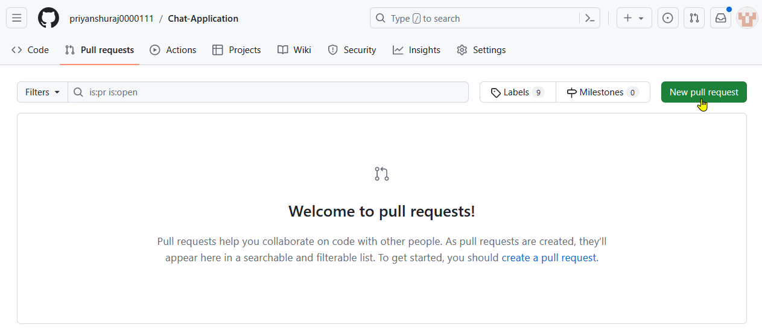

  - Select the Create pull request button and resolve the merge comments

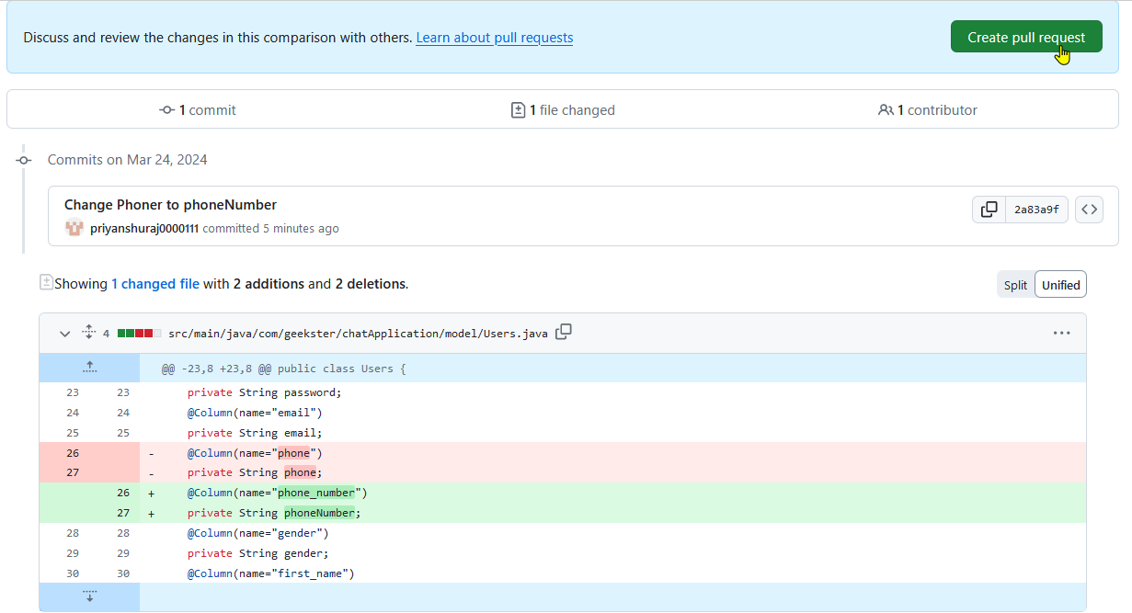

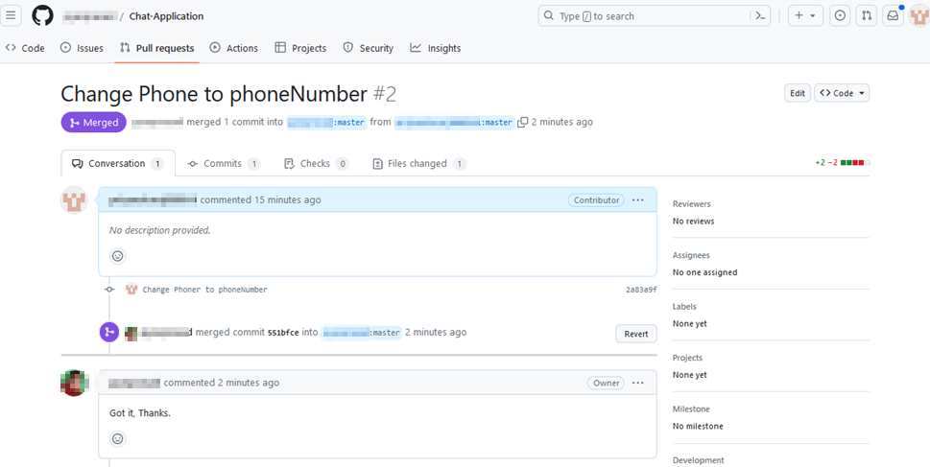

By following these steps, you have successfully created a pull request for merging the local changes into a remote Git repository.

